Certificate of Accomplishment
Awarded to:
«First_Name» «Last_Name»
In recognition of meeting in fellowship, respect, love and understanding and the successful completion of Holy Rosary's Alpha Program.
Romans 12:11-13 " Never give up; be on fire in the Spirit as you serve the Lord! Rejoice in hope, be patient in suffering, persevere in prayer, Share with God’s people who are in need of help, and practice hospitality."
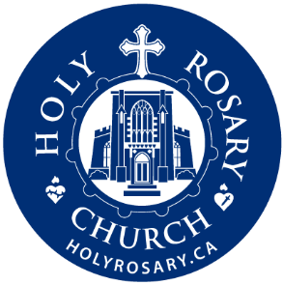

«Date»

«Pastor_Name»
Pastor

